Quality of Life Outcomes Among Participants in an Inclusive Postsecondary Education Program at a Mid-Atlantic University

By: Ann Marie Licata*, James W. Conroy*

*PhD Candidate, College of Education and Human Services, Millersville University, Millersville, Pennsylvania
*Center for Outcome Analysis, Havertown, Pennsylvania

Keywords: secondary education, intellectual disability, outcomes, quality of life, inclusion

Abstract
Students with intellectual disabilities attending an inclusive postsecondary education (IPSE) program were interviewed about their perceptions of changes in qualities of life, as well as their use of time, autonomy, goals, and relationships. The results supported the conclusions that the students perceived significantly improved qualities of life, large increases in autonomy, and evidence of making new friends on campus. The method relied on students’ memory, and future work must utilize true pre and post designs to attain higher scientific confidence. Nonetheless, the results were strongly positive and supported the continuation and expansion of the model. Variations in IPSE models and degrees of campus inclusiveness are discussed.

Introduction

In 2008, the Higher Education Opportunity Act (HEOA) opened the doors for students identified with intellectual disability (ID) to participate in college experiences. In support of this effort, the United States Department of Education has made available Transition and Post-Secondary Program for Students with Intellectual Disability (TPSID) competitive grants for colleges and universities to develop demonstration sites or model programs. This groundbreaking initiative has resulted in over 309 new programs across the country (Grigal et al., 2021a).

Viewed as revolutionary by some, the recent inclusion of students with ID participating in colleges demands evaluation of short- and long-term outcomes (Campbell, 1969; Sheppard-Jones et al., 2018). With the third round of five-year funded TPSID grants awarded in 2020, the TPSID demonstration sites often referred to as inclusive postsecondary education (IPSE) programs continue to require analysis by practitioners and scholars in the field. Coordinated by the efforts of Think College which is “a national initiative dedicated to developing, expanding, and improving research and practice in inclusive higher education for students with intellectual disability” (https://thinkcollege.net/), IPSE programs throughout the country are aiming to develop authentically inclusive college initiatives for young adults with ID ages 18-26. The present study was designed to support programmatic development by assessing short-term on-campus outcomes such as inclusion, friendships, use of time, autonomy, goal attainment, and qualities of campus life for students participating in one of these IPSE programs.
Research in this vein has shown marked improvements for students with ID, ranging from increased knowledge and skills to new friendships (Nasr et al., 2015) and increased self-esteem (Uditsky & Hughson, 2012; Sheppard-Jones et al, 2018). Similarly, students with ID enrolled in IPSE reported growing in self-determination and self-awareness while in college (Ankeny & Lehmann, 2011).

In their effort to collect meaningful data over years of TPSID funded IPSE programs, the Think College national coordinating center emphasizes long-term employment and life trajectory outcomes. Employment is a typical measure used to assess the long-term effectiveness of an inclusive postsecondary education (Grigal et al., 2018; Migliore et al., 2009; Zafft et al., 2004) with participants who complete TPSID programs reporting as high as 59% having a paid job after one year of program completion (Grigal et.al., 2021b). In addition, there have also been recent calls for assessment of other domains of life as positive outcomes (Sheppard-Jones et al., 2018; Turnbull et al., 2003). Self-determination (Shogren, et.al., 2018), social inclusion, personal development, and emotional well-being are several examples of measures that have been suggested as important outcomes (Turnbull et al., 2003).

This is new ground for program evaluation, just as college for students with ID is a relatively new phenomenon in United States education and takes much of its impetus from two decades of experience in Canada (Uditsky & Hughson, 2012). Program evaluation based upon the Think College Standards, Quality Indicators, and Benchmarks (Grigal, et al., 2011) has been addressed by few practitioners in the field. The work on outcome evaluation at Virginia Commonwealth University’s IPSE program, ACE-IT, is acknowledged to be exploratory and largely qualitative (Lynch & Getzel, 2013) in nature. Through a systematic qualitative content analysis of the data associated with the ACE-IT program, Lynch and Getzel concluded that implementing IPSE programs with fidelity to the Think College Standards results in positive outcomes for students in academic, personal, social and career-related skills. Clearly additional studies on program outcomes that align with Think College Standards and focus on the need to address aspects of development in the affective domain of relationship building and maintaining, goal setting, and overall life satisfaction are warranted.

This article addresses the necessity for research analyzing the quality of life of students with ID enrolled in IPSE programs. The research reported in this article reaches beyond employment outcomes by assessing how students spend their time, their perceived quality of life, the level of control in making decisions, their progress at reaching their goals, and their relationships with other members of the campus community.

Methods

Design and Procedures

This outcome evaluation was designed to address immediate quality of life factors in the experiences of students with intellectual and developmental disabilities who enroll in college. In the long run, the purpose of college for these students is the same as for anyone: learning and enhancing economic prospects. The present research team was also interested in more immediate outcomes during the college experience, such as relationships, self-direction, goal attainment, self-reported quality of life, safety both physical and sexual, and freedom from abuse or exploitation.

Prior to full scale field work, an instrument package, described below, was adapted from prior research among people with intellectual and developmental disabilities (Center for Outcome Analysis, 2016) to reflect updated language and college norms. The adapted instrument was tested with three volunteers and was revised for clarity. Internal Review Board approval was sought and received by the university.

The initial design called for face-to-face interviews with incoming students prior to the start of the first semester of college and then longitudinally at the end of each semester thereafter for a total of nine interviews. However, the length of the IRB review process forced the researchers to miss the time window in August to obtain ‘pre’ college interviews. Subsequently, a modified interview approach was taken from past studies with essentially the same instruments, called the ‘Then and Now’ format. Rather than true ‘Pre and Post’ interviews, participants were asked to recall how they would have answered the questions ‘Then’, before they entered college, and also to answer for ‘Now’, while enrolled and on campus. This approach is considerably weaker than the true ‘Pre and Post’ design. Yet it had been used in several studies before, and in a few cases both the ‘Then’ and ‘Now’ and the true ‘Pre and Post’ methods had been utilized for the same samples of individuals (Conroy et al., 2002). Three of the scales (Time, Goals, and Closest Relationships) were designed as current situation only, rather than ‘Then and Now’. The results were found to be subject to some memory loss and bias, but in general to produce results like those from the more rigorous ‘Pre and Post’ design (Conroy & Seiders, 1998).

Students in this study were given the choice of having another close adult (coach, advisor, or friend) present during their interview. This enabled respondents to check with a trusted ally about their understanding of the questions. Close adults could also provide prompts for memory and interpretation. In practice, only one of the students requested and required major support during the interviews.

Training of three student intern interviewers was conducted in April 2017. All interns identified as female and were between the ages of 21-26. They were graduate students whose majors included: social work, school psychology, and geoinformatics. The training session required two hours, followed by role playing interviews and follow up on concerns and questions regarding administration of the instrument. The interns reached a high confidence level that they would be able to perform the interviews rigorously and with fidelity to the training given; accuracy of the practice sessions conducted supported this conclusion.

The ‘Then and Now’ interviews were completed in October 2017. The comparisons of ‘Then and Now’ were calculated for each item and for the scale scores.

Instruments

The researchers intended to add to and extend the work of scientific peers working in the field of IPSE and Think College network (Lynch & Getzel, 2013). The evaluation standards issued by Think College emphasized long term academic performance and employment (Grigal et al., 2011). The researchers wanted to add immediate measures. such as relationships, self-reported qualities of life, autonomy, and goal attainment.

Measures and scales were adopted that had been in wide use among people, families, programs, and projects for people with ID for decades (Center for Outcome Analysis, 2018). The instruments to measure choice-making, integration, and quality of life had been submitted to several tests of reliability over the years (Conroy, 1995; Dodder et al., 1999; Fullerton et al., 1999). The team revised, tested, revised again, and then applied these measures with each of the 15 participants during the Fall 2017 semester.

A crucial feature of the approach adapted from prior protocols developed by the Center for Outcome Analysis (COA, www.eoutcome.org) is the question format. ‘Yes/No’ questions have been reported as unreliable (Sigelman et al., 1981a) and thus, avoided. To avoid the issue of Response Acquiescence, ‘Either/Or’ questions were asked (Sigelman et al., 1981b). More detailed 5-point responses can be obtained in a very simple and clear interview method, used and documented by Sigelman’s research over decades. The key is to ask ‘Either-Or’ questions, which yield response rates just as high as ‘Yes-No,’ and not threatened by acquiescence (Sigelman et al., 1981b). Asking two ‘Either-Or’ questions will produce a 5-point scale, which is more sensitive to nuance and more reliable than 2 point ‘Yes-No’ items (Sigelman et al., 1983). The general instructions used by COA are reproduced below.

Ask each question as an Either-Or inquiry, followed by another Either-Or probe for more detail. Example: Ask “How do you feel about living here, Good or Bad?” If the person answers ‘Good,’ then you probe with “OK, would you say Good or Very Good?” On our 5-point scales, a 4 is Good and a 5 is Very Good. If the person answers “I don't know,” or “Not sure,” or some indefinite answer, probe with “Do you feel on the good or bad side?” If no preference, stick with “Fair,” which we will interpret to mean ‘In Between’ – which is a ‘3’ on a 1-to 5-point scale (Center for Outcome Analysis, 2016).

The instrument package utilized in this study is summarized in Table 1. The full 2017 package can be viewed at www.eoutcome.org.

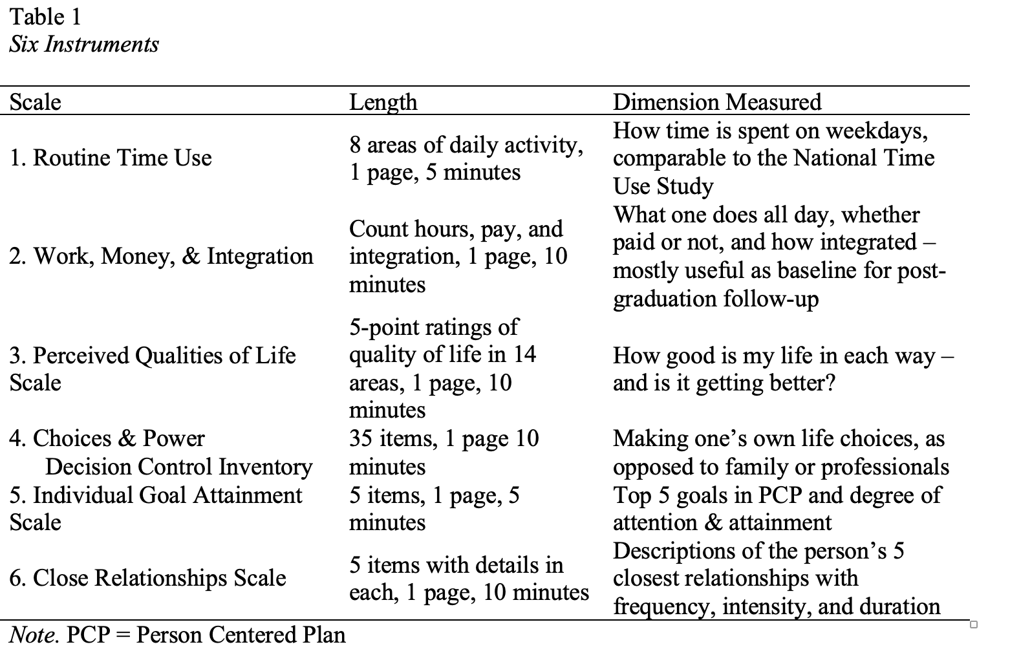

The broad qualities of life measurement approach adopted for this outcome evaluation was supported and encouraged recently in an article titled Life Outcomes and Higher Education: The Need for Longitudinal Research Using a Broad Range of Quality of Life Indicators (Sheppard-Jones et al., 2018). They pointed out that future researchers need to look beyond employment and investigate how postsecondary education impacts health and wellness, relationships, community inclusion, and self-determination. Those authors urged broader consideration of life outcomes, longitudinal designs, and comparison groups. The pilot tests reported here include the first two aspects.

The instrument was initially pilot tested with eight volunteer college students identified with ID. Minor revisions and format modifications were made, and the package was finalized for field use. Revisions included providing visual scales for the participants to assist in selecting their response. There were also several vocabulary words changed to update for young adults in a college setting.

Participants

Research efforts focused on 15 college students at a Mid-Atlantic IPSE program which serves as a model TPSID program. Students in this IPSE program engaged in fully inclusive college experiences where they audited all course work, registering for 12-15 credit hours. This full-time program offered students the option of receiving a two-year or four-year meaningful credential consistent with the university’s approved curriculum. The curriculum allowed for each student’s interest to be met. Course selections were selected in conjunction with individual faculty advisors accessing classes from the university’s course catalog consistent with the chosen curricular major. Students lived on campus full-time with typical peers. Relationship skills were embedded in the everyday experiences that college life offers. The liberal arts curriculum provided intentional support as students receive paid work experience throughout their college years which ultimately leads to 15 times greater success in receiving competitive integrated employment after completion of the program (Grigal et al., 2018). Students receive support from mentors and educational coaches throughout the time they are at the university.

The first application of the instruments and methods relied on memory with the 15 students as participants in the IPSE program ranging from three to fifteen months. Students were contacted early after arrival on campus to obtain informed consent, then contacted again later via e-mail or texting to arrange an hour for the interview. Interviews were scheduled and conducted in faculty or staff offices. A few students took longer than an hour to answer the questions, and a few completed the work in two sessions. Group debriefing of interviewers indicated that the participants generally found the interviews pleasant and sometimes thought-provoking, particularly the section on goals. Some students were observed to show signs of weariness with interviewers noticing visible signs such as yawning or holding their head in their hand.

The 15 college students ranged in age from 19 to 25 with a mean age of 21.4 years. There were eight females and seven males in the group. Self-described ethnicity was reported as six Caucasian / European, five African-American / Black, two Mixed, one Other, and one ‘That’s Private.’ All students identified as having ID. Self-reported significant mobility challenges were reported by two students, mild and correctible sensory impairments by two, and significant difficulties with controlling one’s own behavior by one. Regarding “Communicating with people I don’t know”, two students reported needing a lot of support, and three needed a little support.

Analysis

Data were collected in the Fall 2017 semester on paper forms and entered in a common spreadsheet. These data were then read into the Statistical Package for the Social Sciences (SPSS) (Nie et al., 1975). Statistical procedures utilized included Frequencies, Descriptive Statistics, Crosstabs, and simple Group and Paired t-tests.

Results

Reliability – Internal Consistency

Reliability of the major scales was investigated in the form of internal consistency, using the commonly employed Cronbach’s Alpha.

For the Quality-of-Life Scale, Alpha for the ‘Then’ form (recalling what life was like just before coming to campus) was .865. For the ‘Now’ form, Alpha was .872. Both were acceptable and were considerably above the commonly accepted level of desirability, which is .800.

For the Decision Control Inventory (DCI), about the freedom to take part in one’s own life choices, Alpha for the ‘Then’ form was .876, and for the ‘Now’ form .751. The lower Alpha on the ‘Now’ data was investigated, but no clear explanation emerged.

Short Scales

Time Use
One of the most basic questions is about how a student spends his or her time. We designed our survey around the American Time Use Survey (ATUS) of the Department of Labor, Bureau of Labor Statistics (American Time Use Survey, 2017). The ATUS recently issued data specifically for college students, hence we could compare our sample of students’ use of time to the average in the nation. In Table 2, the column headed “Sample” shows average hours per day for the 15 students in our sample.

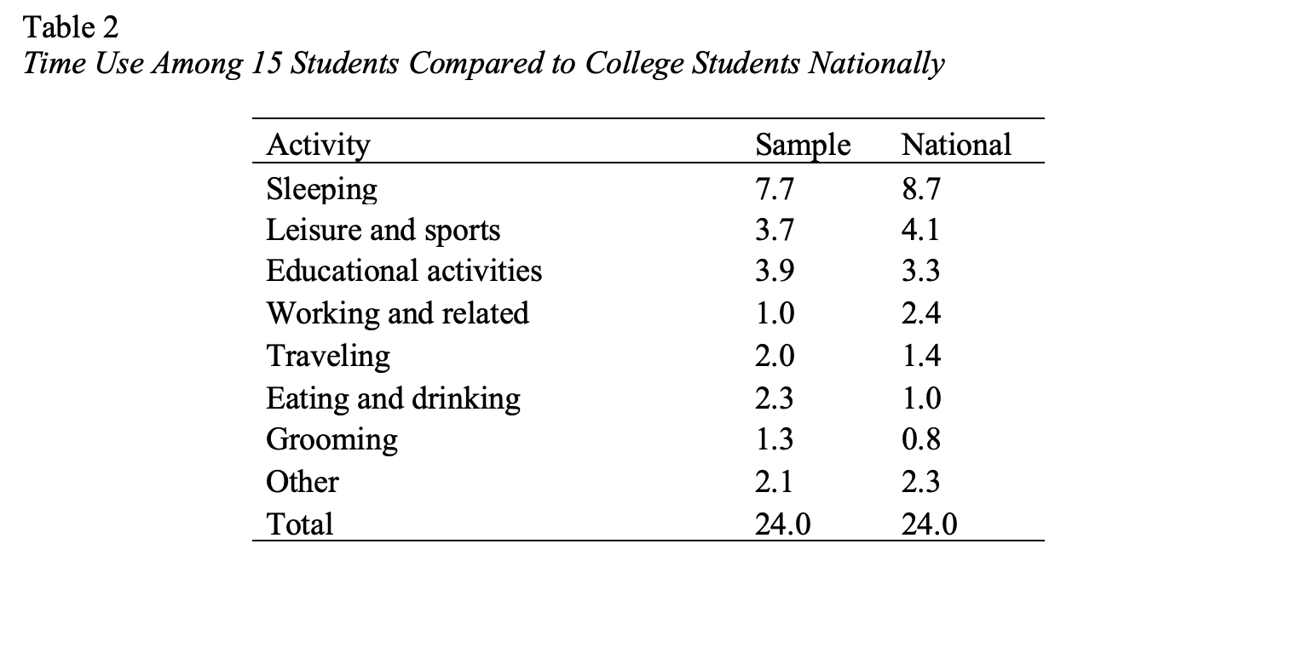

The students in our study described their current college patterns of time use. The interviewers were trained to walk through an average day with the respondents, with times of getting up, classes, meals, studying, recreation, and bedtime. Students selected an average day during the week and interviewers assisted each one by starting with 24 hours written on a paper. Students were asked to provide the approximate number of hours that they slept each night, went to class, ate meals, etc. The time allotment was subtracted from the overall all 24 hours, providing a visual prompt for the student. The results are shown in Figure 1.

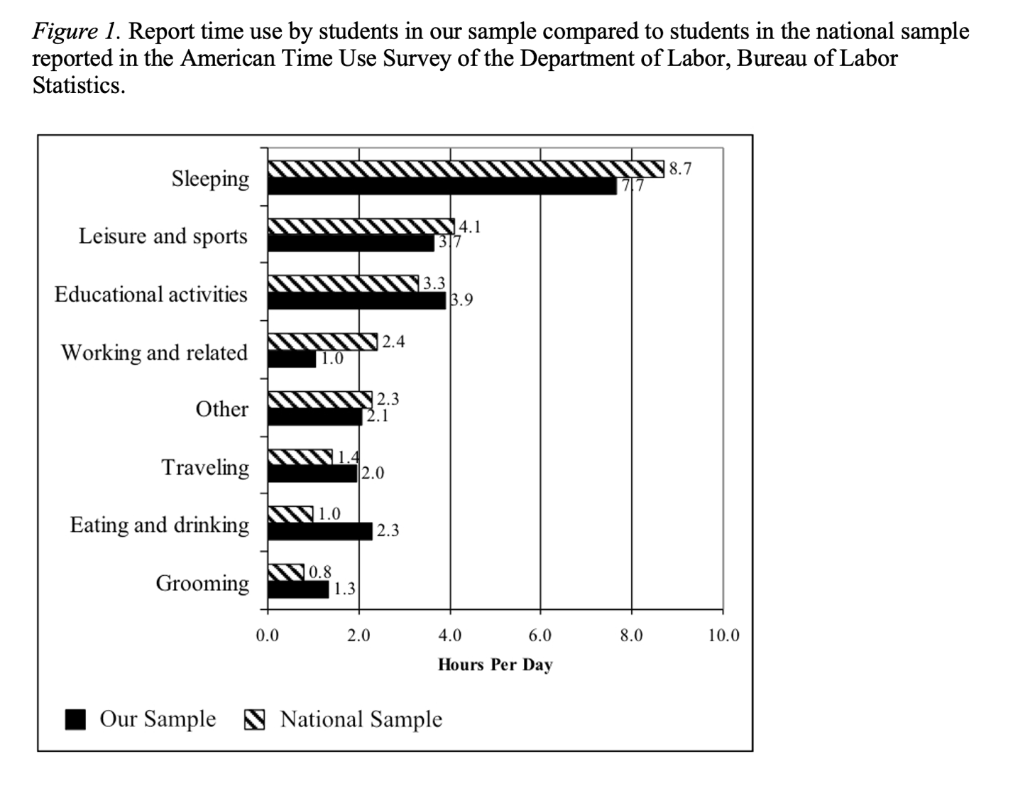

The participants were spending about an hour less time sleeping than the national college student average – 7.7 hours versus 8.7 hours. Participants in our study had less time on leisure and sports, and more time on educational activities. Further, they noted spending less time on paid work, though in the interviews many reported that they hoped to get jobs after ‘settling in’ on the college campus. The students in our study spent more time on traveling, eating and drinking, and grooming than the national college average. Figure 1 shows the findings in visual format.

Working, Earnings, and Integration

Four of the 15 students or nearly 27 percent were working for pay at the time of the interviews. These students reported working an average of 7.5 hours each week. The weekly average earnings were $45.50. Two students reported volunteering on campus at an average of 5.5 hours each week.

Perceived Qualities of Life Scale, College Student Version

The Perceived Qualities of Life Scale was designed to obtain each student's sense of changes in life experience upon entering college, and in the years ensuing. In this study, we asked the students to recall their experience before college (‘Then’), and now, in college (‘Now’).

Table 3 is sorted by the magnitude of difference between ‘Then’ and ‘Now’. This allows us to see quickly where the largest perceived changes were.

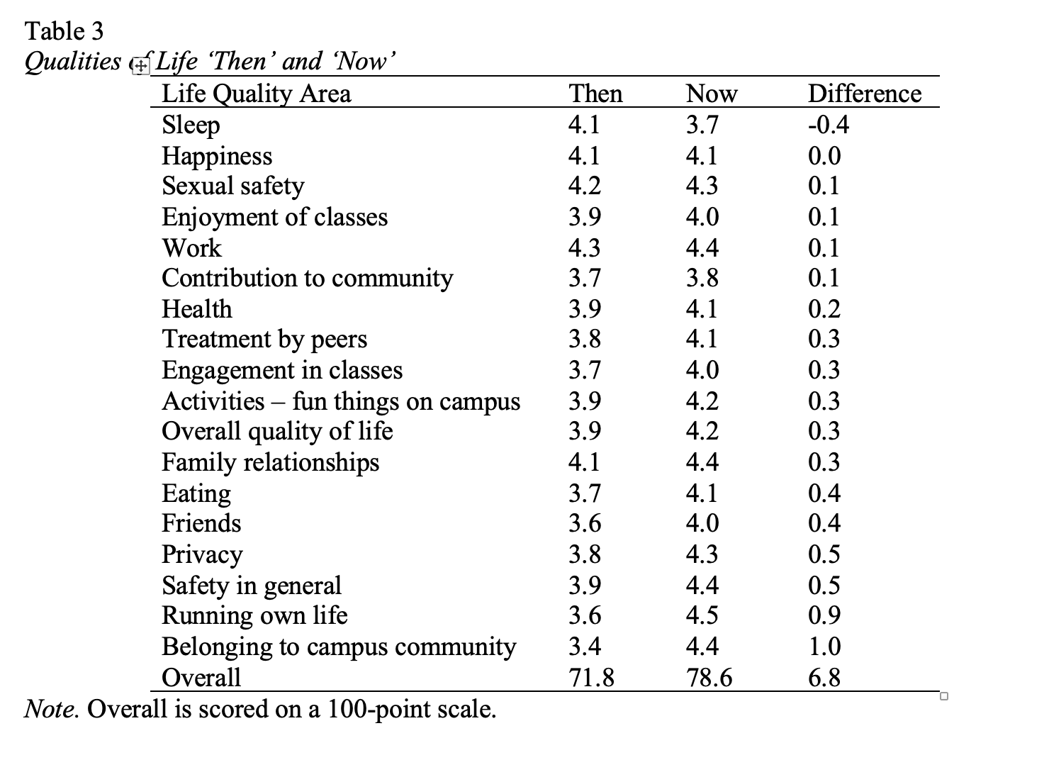

The only area of decrease in quality of life was sleep (negative 0.4 on the 5-point scale). This corresponds with the finding that these students were sleeping about an hour less per night than the average U.S. college student. Future research will seek to confirm or question this preliminary finding, and if confirmed, learn about the reasons for the phenomenon.

The largest perceived changes between home and campus were in “running your own life” and “belonging – feeling a part of the community.”

The 18 items were combined into a single overall 100-point scale for general investigation. This last row in the table shows that the overall Perceived Quality of Life Scale increased from 71.8 to 78.6, an increase of 6.8 points. This difference was statistically significant by the standard tests. (The Wilcoxon Z is a nonparametric test, designed to be appropriate for samples with small N or non-normal distributions. Its value was Z =1.678, 1 tailed significance p = .047. If we use the more familiar parametric test, Student’s t = 2.103, 13 degrees of freedom, 1 tailed significance p = .0280. Thus, the parametric and nonparametric tests yield similar results – a common outcome based on the “robustness” of the parametric tests to violations of its assumptions.)

Choices – Decision Control Inventory, College Version

The Decision Control Inventory was designed to detect changes in autonomy – the extent to which people participate in their own life choices. Table 4 is sorted by the amount of difference between ‘Then’ (back at the family home) and ‘Now’ (on campus). Table 4 shows that of the 29 areas measured, 27 showed increases, while only 2 decreased.

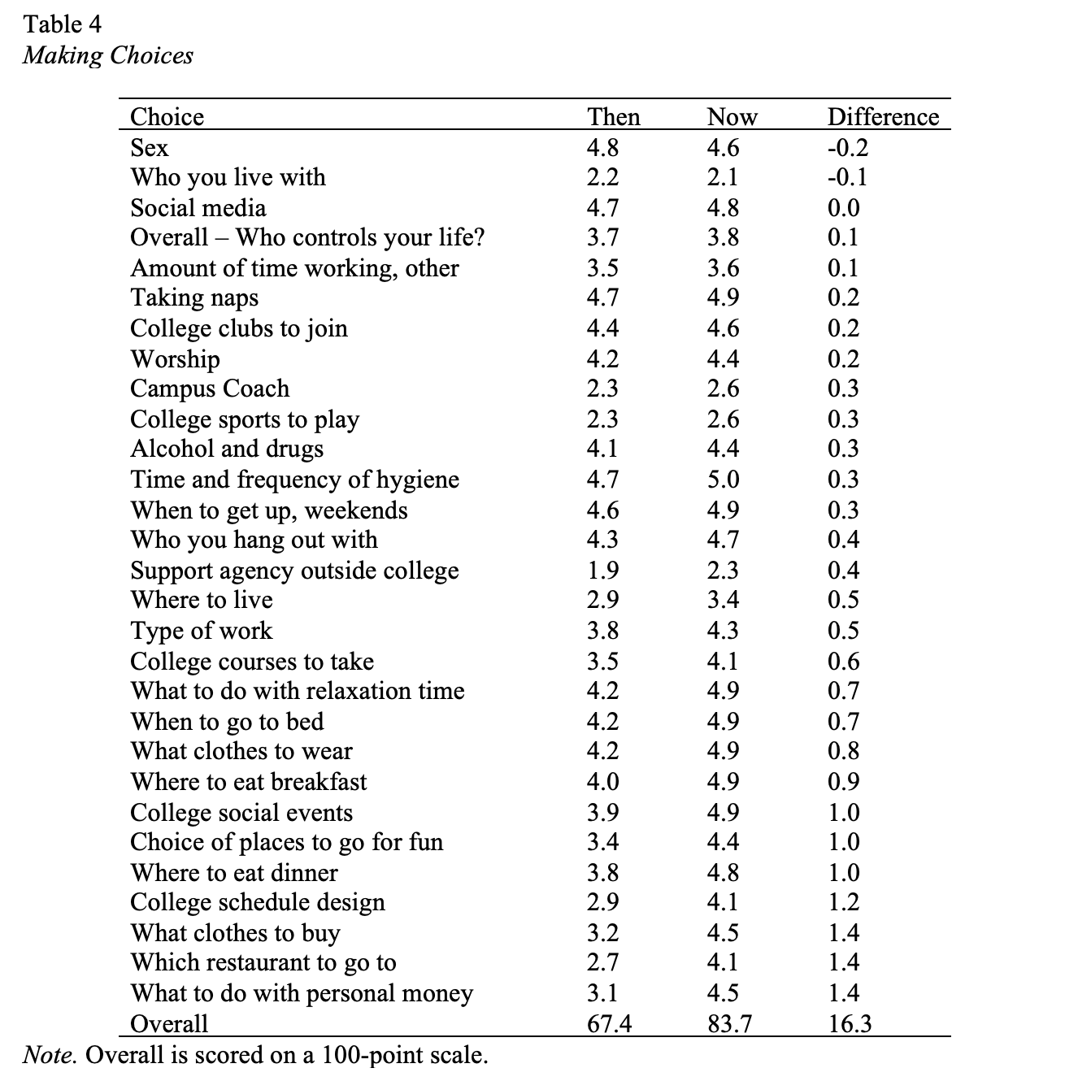

The decreases were in the responses to sex and who you live with. The largest increases at the bottom of the table were reported in what clothes to buy, what restaurants to go to, and what to do with personal money.

Again, the items were combined into a single 100-point scale. This overall choice making scale score went up from 67.4 to 83.7, an increase of 16.3 points. This overall increase was statistically significant. (Nonparametric Wilcoxon Z = 2.981, 1 tailed significance p = .0015; parametric t = 3.385, 12 degrees of freedom, 1 tailed significance p = .0025.)

The significant increase in choice making shows that, for this group of students, the freedom to make life choices was perceived to have increased rather sharply when the students came to campus.

Progress Toward Individual Goals

The students were asked to list their top five goals in the current year of college. They were not asked to report on goals prior to college. The degree to which these goals were achieved, or in the process of being achieved, was rated on a 1-to 5-point scale. Table 5 shows how participants were asked about their goal progress.

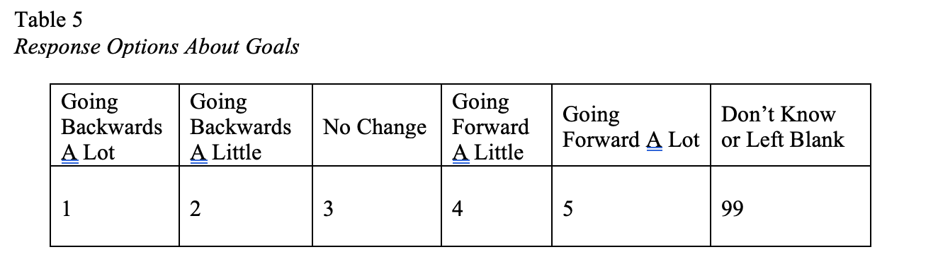

Table 6 shows the results of the students’ self-ratings of progress toward goals.

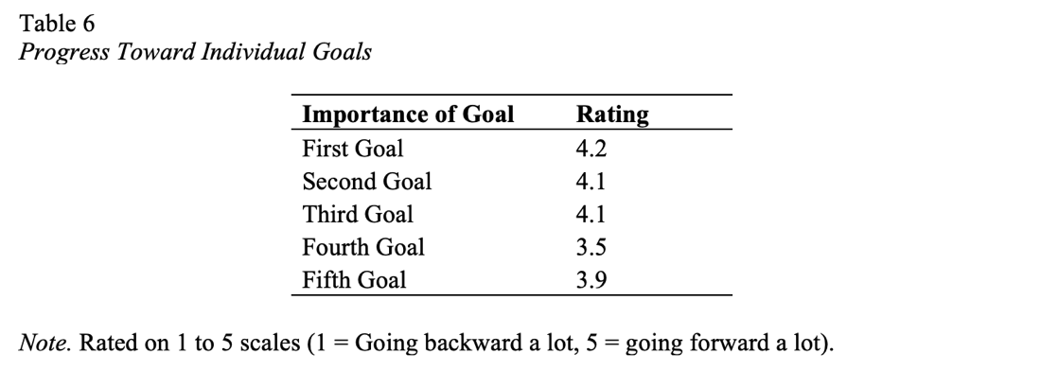

The ratings were generally quite positive. The pattern indicated more progress toward the more important goals.

Some examples of the specific goals stated by the students are shown in Table 7. It should be noted that some of the goals are long term. Moreover, this listing of examples is in alphabetical order, not in any priority sequence.

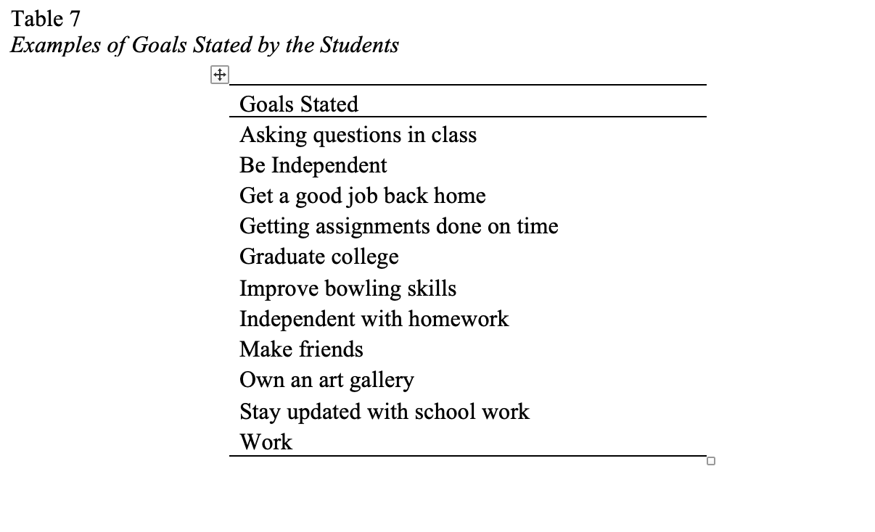

Close Relationships

The close relationships part of the survey asked each of the 15 students to enumerate and describe the five closest relationships in their lives now. (There was no ‘Then’ and ‘Now’ component of this question; pilot testing had shown it to be too difficult.) In addition, students were asked to describe each relationship (i.e., friend, relative, teacher, etc.). Other aspects of each relationship were included, but for the moment we focus on the type of relationships. Table 8 shows the distribution.

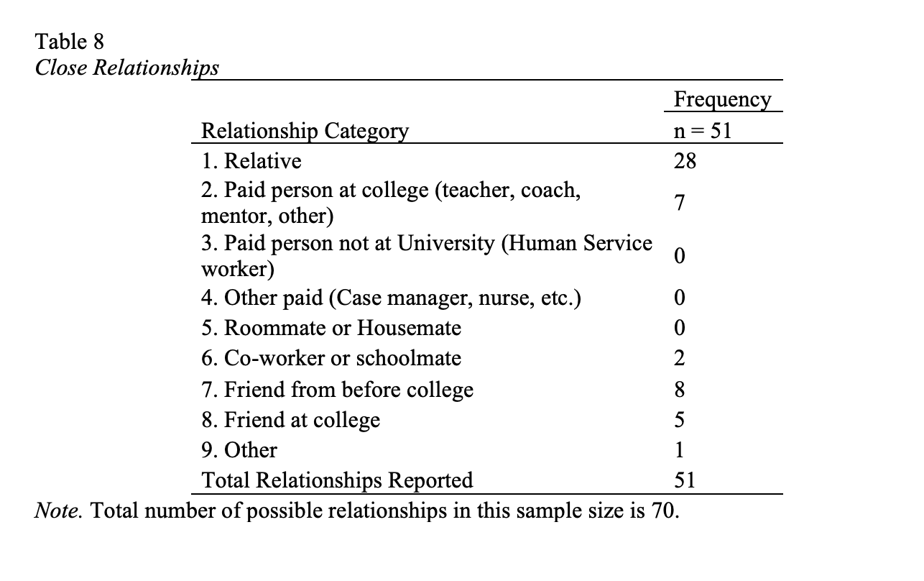

An overall total of 51 of a possible 75 close relationships were reported. The most common close relationship was with relatives (28). Next, participants reported friends from before college (8) teachers, mentors, or coaches at college (7), and friends made at college (5).

The Interviewing Process

The interviewing process was successful in that students were open and positive about being interviewed and were willing to be interviewed again in the future. In some instances, students opted to have another close adult (coach, advisor, or friend) present during their interview. Due to the ‘Then’ and ‘Now’ method of investigation, the length of interviews tended to exceed the predicted time allotment of one hour. As a result, some interviewees required a break during the interview, while others required two sessions. Moreover, the ‘Then’ and ‘Now’ memory method has allowed for self-reflection of the changes the students have experienced since coming to college.

Discussion

This study applied several measures to shed light on the perceived qualities of life of a small sample of college students identified with ID in an IPSE program. The measures were adapted from instruments used with the same population in other contexts. In general, the study supported the conclusions that this sample of students perceived increased qualities of life, increased opportunities for choice and independence, strong progress toward unique individual goals, and maintenance of relationships with encouraging suggestions of new relationships on campus.

The outcome measures, derived from decades of work among people with disabilities, are working well in terms of interviewing flow and reliability. The original reliability studies of the source instruments showed strong results (Conroy, J., 1995; Dodder et al., 1999; Fullerton, et al.,1999). Some of the measures in this study were measures of current situation only, e.g., time use, goals, and close relationships. Many measures were designed to employ memory to detect perceptions of change in qualities of life since entering college. These ‘Then and Now’ measures appeared to contain sufficient detail to detect changes, and patterns of changes, among students entering college. A prior attempt to elucidate quality of life outcomes among students (Sheppard-Jones et al., 2018) utilized a different instrument, the National Core Indicators (Human Service Research Institute and National Association of State Directors of Developmental Disability Services, 2012) with positive results, but with less detail than the current research team sought.

Compared to the national average, students in this study reported spending less time sleeping and working, while spending more time engaged with eating, drinking and mealtimes. They also spent more time studying and traveling. The finding on mealtimes suggests the importance of food related activities to social integration. The students’ mealtime is predictable and flexible, as the time and locations of access to food are common to all college students. This provides opportunity for socializing, personal networking, and choices in menus. Simple time use is an objective measure that can be compared to national data via the American Time Use Survey (2017) and may be a fruitful area for further research.

The increases in quality-of-life dimensions were led by belonging to campus community and running own life, which was possibly a natural result of moving from home to living full time on campus. In addition, positive changes were found in family relationships, eating, friends, privacy, and safety in general. The overall change across all domains of quality of life was about seven percent. Thus, it was clear that students felt positive about their early experience in college.

The decrease in choices about sex could reflect enhanced awareness and caution in a new environment, possibly with the advice of concerned family members. The decrease in choice about who you live with may reflect this college’s practices of assigning roommates. The increases in what to do with personal money, which restaurant to go to, and what clothes to buy seem interpretable and credible when considering the change from parental oversight to campus life.

Students in our study reported that they were achieving their goals to a high degree at approximately 4-points out of a 5-point scale. This self-perception suggested a convincing sense of self-efficacy, which in turn, may have led to higher probability of goal attainment. Achievement of personal goals has broad implications for quality of life and achieving a good life including the need for higher meaning and purpose, respect, social inclusion and belonging, close relationships, contribution, and voice and choice (Elks, 2020).

With the relationship findings, the researchers observe that relationships with relatives are by far the most common, with old friends placing second, and new friends at college coming in third. The finding that students were making new friends is viewed as encouraging for participation in campus life and enjoyment with their experience.

Limitations and Future Research

The method of using students’ memory to report whether they are better off is imperfect. Future work is proceeding to implement true pre and post designs. After pre and post designs are implemented, the next improvement will be the addition of comparison groups of several kinds, including typical college peers and students from other IPSE programs. Longitudinal studies with students after college will be essential and most revealing. Studies of longitudinal employment outcomes in the overall IPSE initiatives are encouraging with 66% of program completers reporting a paid job after two years (Grigal et al., 2021b). Grigal et al. also found that 92 percent of former IPSE students report being satisfied or very satisfied with their social life.

Future studies are needed that compare qualities of life, achievement, close relationships, and employment in college programs with varying levels of inclusion, (i.e., programs that require specialized courses as part of the curriculum versus those that have all college courses as part of the University’s course catalog). Studies in the future must include significant attention to family perceptions of the college experience, particularly about qualities of life, relationships, and goals. Comparison of students’ perceptions of quality of life in college and families’ perspectives will offer even further insights into expectations and self-efficacy.
Implications for Practice

This research adds to the current body of literature in considering fully inclusive college participation for young adults with intellectual disability. The overall results of this study were primarily positive. Students reported feeling that their lives had improved significantly in several areas, including more control over their own lives (and were pleased about it), they felt included, they were making progress toward their unique goals, and they were making new friends on campus.

Attention to relationships, with all due respect for student privacy, should be part of program practice. The current efforts to measure relationships, both maintaining old ones and forming new ones, have been viewed by students in this IPSE program as helpful. The data are valuable in that signs of isolation and loneliness are not being reported. That will be of considerable comfort to families and prospective students. If such signs had been seen, remedies would be deemed necessary.

This research focused on outcomes during the college experience, rather than after completion. This corresponds to conducting ‘formative’ as well as ‘summative’ evaluation. Formative evaluations are intended to help program designers, managers, and implementers to address challenges to the program's effectiveness, whereas summative evaluations seek to determine whether the program should be continued, replicated, or curtailed. Emphasis on formative study of student life in IPSE programs should be considered standard practice as part of the effort to make programs ‘better’ year after year.

The quantitative and reliable measurement of qualities of life in the formative methodology is challenging. The current methods and instruments may provide a strong beginning step, but improvements are needed. The effort to assess aspects of program impacts in quantitative ways, aspects that are usually addressed only qualitatively, is worthy of attention in practice. IPSE programs should work together in conjunction with Think College to assure growth and consistency of attention to measurable, formative outcomes including qualities of life and relationships are addressed.

Given that this set of data are reported on participants in an IPSE program which includes fully integrated residential living on campus, no specialized courses, and the same types of college struggles and challenges that other students on campus are experiencing, it might be beneficial to consider the level of response that may occur from students who participate in programs that are not residential and offer specialized curriculum to learn if there is a difference. One might speculate that the authenticity of the college experience for students within this program added to their generally positive responses. Further, one might find that experiences in college that promote the expectation of being fully included like all other students in every respect might present inherent challenges for families who have advocated for their family members identified with ID prior to the college experience. Consideration should be given to the impact that families’ perspectives have on their college student’s IPSE experience and how the data reflects this influence, suggesting a need for further investigation and examination.

How do these varying family perspectives influence IPSE programs to foster college experiences that are less than fully inclusive? The relationship between family expectations for fully inclusive college experiences and a student’s perceived quality of life in college may indicate that programs need to reflect on program design, marketing, and student selection to enhance the experience for all.

References

American Time Use Survey (2017). Department of Labor, Bureau of Labor Statistics. Home page at https://www.bls.gov/tus/home.htm

Ankeny, E. M., & Lehmann, J. P. (2011). Journey toward self-determination: Voices of students with disabilities who participated in a secondary transition program on a community college campus. Remedial and Special Education, 32, 279 -289. https://doi.org/10.1177/0741932510362215

Campbell, D.T. (1969). Reforms as experiments. American Psychologist, 24(4), 409-429. Center for Outcome Analysis (2016). Personal Life Quality Protocol: Short, Reliable Outcome Measurement Tools for Quality Tracking in Developmental Disabilities Systems. COA, available at http://eoutcome.org/Uploads/COAUploads/PdfUpload/COA-PLQ-Instruments-WithThen&NowVersions-V56.pdf

Conroy, J. (1995, December). Reliability of the Personal Life Quality Protocol. Report Number 7 of the 5 Year Coffelt Quality Tracking Project. ubmitted to the California Department of Developmental Services and California Protection & Advocacy, Inc. Ardmore, PA: The Center for Outcome Analysis.

Conroy, J., Fullerton, A., Brown, M., & Garrow, J. (2002, December). Outcomes of the Robert Wood Johnson Foundation’s National Initiative on Self-Determination for Persons with Developmental Disabilities: Final Report on Three Years of Research and Analysis. Submitted to the Robert Wood Johnson Foundation as the Impact Assessment of the Foundation’s National Initiative entitled Self-Determination for Persons with Developmental Disabilities. Narberth, PA: Center for Outcome Analysis.

Conroy, J., & Seiders, J. (1998, June, revised October, 1998). The Coffelt Quality Tracking Project: The Results of Five Years of Movement From Institution to Community. Final Report (Number 19) Of the Coffelt Quality Tracking Project California Department of Developmental Services. Submitted to the California Department of Developmental Services and Protection & Advocacy Inc. of California. Rosemont, PA: Center for Outcome Analysis.

Dodder, R., Foster, L., & Bolin, B. (1999). Measures to monitor developmental disabilities quality assurance: A study of reliability. Education and Training in Mental Retardation and Developmental Disabilities, 34, 66-76.

Elks, M. (2020). Remarkable similarities in four list theories of a good life for people with intellectual disability. Journal of Intellectual Disabilities, 24 (3), 418-426.

Fullerton, A. Douglass, M. & Dodder, R. (1999). A reliability study of measures assessing the impact of deinstitutionalization. Research in Developmental Disabilities, 20, 387-400.

Grigal, M., Hart, D., & Alston, S. (2021a, July 19-20). Opening Plenary [Conference session].
TPSID Project Director Meeting, virtual conference. https://whova.com/portal/webapp/tpdm_202107/Agenda/1636043.

Grigal, M., Hart, D., Papay, C., Wu, X., Lazo, R., Smith, F., & Domin, D. (2021b). Executive
Summary of the Annual Report of the TPSID Model Demonstration Projects (Year Five, 2019-2020). Think College Fast Facts, Issue No. 30. Boston, MA: University of Massachusetts Boston, Institute for Community Inclusion.

Grigal, M., Hart, D., Smith, F. A., & Papay, C. (2018). Year two student data summary (2016-2017) of the TPSID model demonstration projects. Boston, MA: University of Massachusetts Boston, Institute for Community Inclusion

Grigal, M., Hart, D., & Weir, C. (2011). Think college standards, quality indicators, and benchmarks for inclusive higher education. Boston, MA: University of Massachusetts Boston, Institute for Community Inclusion.

Grigal, M., Papay, C., Smith, F., Hart, D., & Verbeck, R. (2019). Experiences that predict employment for students with intellectual and developmental disabilities in federally funded higher education programs. Career Development and Transition for Exceptional Individuals, 42, 17–28. https://doi.org/10.1177/2165143418813358

Human Services Research Institute and National Association of State Directors of Developmental Disabilities Services. (2012). Using National Core Indicators (NCI) data for quality improvement initiatives. Retrieved from http://www.nationalcoreindicators.org/upload/core-indicators/using_national_core_indicators_data.pdf

Lynch, K. & Getzel, E. (2013). Practice brief: assessing impact of inclusive postsecondary education using the think college standards. Journal of Postsecondary Education and Disability, 26, 385-393.

Migliore, A., Butterworth, J. & Hart, D. (2009) Postsecondary education and employment outcomes for youth with intellectual disabilities. Think College Fast Facts, Issue No. 1. Boston, MA: University of Massachusetts Boston, Institute for Community Inclusion.

Nasr, M., Cranston-Gingras, A., & Jang, S. (2015). Friendship experiences of participants in a
university-based transition program. International Journal of Whole Schooling, 11(2), 1-15.

Nie, N. H., Hull, C., Jenkins, J., Steinbrenner, K., & Bent, D. (1975). SPSS: Statistical Package for the Social Sciences. 2nd ed. New York, McGraw-Hill, 1975.

Sheppard-Jones, K., Kleinert, H., Butler, L., & Whaley, B. (2018). Life outcomes and higher education: The need for longitudinal research using a broad range of quality of life indicators. Intellectual and Developmental Disabilities, 56, 69-74. https://doi:10.1352/1934-9556-56.1.69

Shogren, K. A., Wehmeyer, M. L., Shaw, L. A., Grigal, M., Hart, D., Smith, F. A., & Khamsi, S.
(2018). Predictors of self-determination in postsecondary education for students with intellectual and developmental disabilities. Education and Training in Autism and Developmental Disabilities, 53(2), 146-159.

Sigelman, C.K., Budd, E.C., Spanhel, C.L., & Schoenrock, C.J. (1981a). When in doubt, say yes: Acquiescence in interviews with mentally retarded persons. Mental Retardation, 19, 53-58.

Sigelman, C.K., Budd, E.C., Spanhel, C.L., & Schoenrock, C.J. (1981b). Asking questions of retarded persons: A comparison of yes-no and either-or formats. Applied Research in Mental Retardation. 2, 347-357.

Sigelman, C.K., Schoenrock, C.J., Budd, E.C., Winer, J.L., Spanhel, C.L., Martin, P.W., Hromas, S.G., & Bensberg, G.J. (1983). Communicating with mentally retarded persons: Asking questions and getting answers. Lubbock: Research & Training Center in Mental Retardation, Texas Tech University.

Turnbull, H. R., Turnbull, A. P., Wehmeyer, M. L., & Park, J. (2003). A quality of life framework for special education outcomes. Remedial and Special Education, 24, 67-74. doi:10.1177/07419325030240020201

Uditsky, B., & Hughson, E. (2012). Inclusive Postsecondary Education—An Evidence-Based Moral Imperative. Journal of Policy and Practice in Intellectual Disabilities, 9, 298–302, December 2012.

Zafft, C., Hart, D., & Zimbrich, K. (2004). College Career Connection: A study of youth with intellectual disabilities and the impact of postsecondary education. Education and Training in Developmental Disabilities, 39, 45-53. Retrieved from http://www.jstor.org/stable/23880020

